ZADACI ZA PONAVLJANJE CJELINE – MNOGOKUTI
194.
peterokut, sedmerokut, osmerokut, četverokut

195.
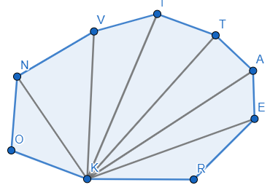
a) Ima 9 stranica. Deveterokut.
b) 6 dijagonala.

196.
a) n = 7
$$D_{n}=\frac{n\left(n-3\right)}{2}=\frac{7\left(7-3\right)}{2}=14$$

b) n = 12
$$D_{n}=\frac{n\left(n-3\right)}{2}=\frac{12\left(12-3\right)}{2}=54$$

c) n = 15
$$D_{n}=\frac{n\left(n-3\right)}{2}=\frac{15\left(15-3\right)}{2}=90$$
d) n = 20
$$D_{n}=\frac{n\left(n-3\right)}{2}=\frac{20\left(20-3\right)}{2}=170$$

197.
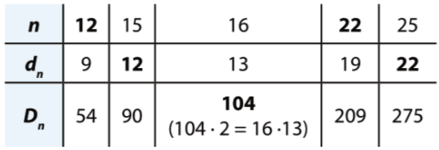

198.
7 dužina 2 stranice i 5 dijagonala
d_{n}=5
n-3=5
n=8
To je osmerokut.
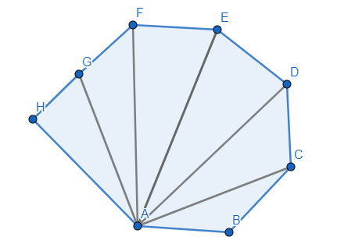
199.
$\frac{n\left(n-3\right)}{2}=6n$ /·2
$n\left(n-3\right)=12n$ / : n
n – 3 =12
n = 15
Petnaesterokut.

200.
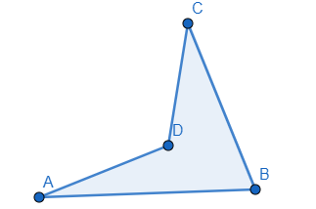
a)

b)
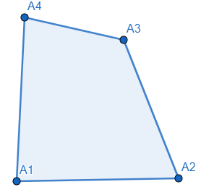

201.
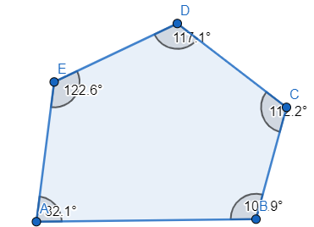

202.
a) $α=160°$
$$β=180°-α=180°-160°=20°$$
$$n=360° :n=360° :20°=18$$
$$K_{n}=\left(n-2\right)∙180°=\left(18-2\right)∙180°=16∙180°=2880°$$

b) $α=165°$
$$β=180°-α=180°-165°=15°$$
$$n=360° :n=360° :15°=24$$
$$K_{n}=\left(n-2\right)∙180°=\left(24-2\right)∙180°=22∙180°=3960°$$

c) $α=162°$
$$β=180°-α=180°-162°=18°$$
$$n=360° :n=360° :18°=20$$
$$K_{n}=\left(n-2\right)∙180°=\left(20-2\right)∙180°=18∙180°=3240°$$

d) $α=144°$
$$β=180°-α=180°-144°=36°$$
$$n=360° :n=360° :36°=10$$
$$K_{n}=\left(n-2\right)∙180°=\left(10-2\right)∙180°=8∙180°=1440°$$

e) $α=168°$
$$β=180°-α=180°-168°=12°$$
$$n=360° :n=360° :12°=30$$
$$K_{n}=\left(n-2\right)∙180°=\left(30-2\right)∙180°=28∙180°=5040°$$

203.
a) $β=36°$
$$n=360°:β=360°:36°=10$$
10 stranica.

b) $β=15°$
$$n=360°:β=360°:15°=24$$
24 stranice.

c) $β=24°$
$$n=360°:β=360°:24°=15$$
15 stranica.

d) $β=22.5°$
$$n=360°:β=360°:22.5°=16$$
16 stranica.

e) $β=11°{15}^{'}=11.25°$
$$n=360°:β=360°:11.25°=32$$
10 stranica.
204.
a) n = 9
$$β=360° :n=360° :9=40°$$
$$γ=\frac{180°-β}{2}=\frac{180°-40°}{2}=70°$$

b) n = 10
$$β=360° :n=360° :10=36°$$
$$γ=\frac{180°-β}{2}=\frac{180°-36°}{2}=72°$$

c) n = 18
$$β=360° :n=360° :18=20°$$
$$γ=\frac{180°-β}{2}=\frac{180°-20°}{2}=80°$$

d) n = 40
$$β=360° :n=360° :40=9°$$
$$γ=\frac{180°-β}{2}=\frac{180°-9°}{2}=85.5°=85°30'$$

205.
a) $β=20°$
$$n=360°:β=360°:20°=18$$
$$D_{18}=\frac{18(18-3)}{2}=9∙15=135$$

b) $β=30°$
$$n=360°:β=360°:30°=12$$
$$D_{12}=\frac{12(12-3)}{2}=6∙9=54$$

c) $β=40°$
$$n=360°:β=360°:40°=9$$
$$D_{9}=\frac{9(9-3)}{2}=9∙3=27$$

d) $β=72°$
$$n=360°:β=360°:72°=5$$
$$D_{5}=\frac{5(5-3)}{2}=5∙1=5$$

e) $β=5°$
$$n=360°:β=360°:5°=72$$
$$D_{18}=\frac{72(72-3)}{2}=36∙69=2484$$

206.
a) $K_{n}=1800°$
$\left(n-2\right)∙180°=1800°$ /:180°
$$n-2=10$$
$$n=12$$
$$β=360° :n=360°:12=30°$$
$$α=180°-30°=150°$$

b) $K_{n}=2880°$
$\left(n-2\right)∙180°=2880°$ /:180°
$$n-2=16$$
$$n=18$$
$$β=360° :n=360°:18=20°$$
$$α=180°-20°=160°$$

c) $K_{n}=5400°$
$\left(n-2\right)∙180°=5400°$ /:180°
$$n-2=30$$
$$n=32$$
$$β=360° :n=360°:32=11.25°=11°15'$$
$$α=180°-11°15'=168°45'$$

207.
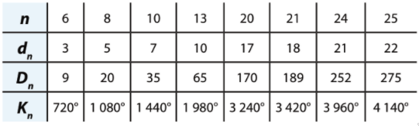
208.
a) n =12
$$β=360° :n=360°:12=30°$$
$γ=\frac{180°-β}{2}=\frac{180°-30°}{2}=75°$
Kut nasuprot osnovice ima veličinu 30°, a kutovi uz osnovicu 75°.
209.
a) $α_{n}^{'}=18°=β_{n}$
$γ_{n}=\frac{180°-β}{2}=\frac{180°-18°}{2}=81°$
n = 360° : 18° = 20 Dvadeseterokut.

b) $α_{n}^{'}=120°=β_{n}$
$γ_{n}=\frac{180°-β}{2}=\frac{180°-120°}{2}=30°$
n = 360° : 120° = 3 Trokut.

210.
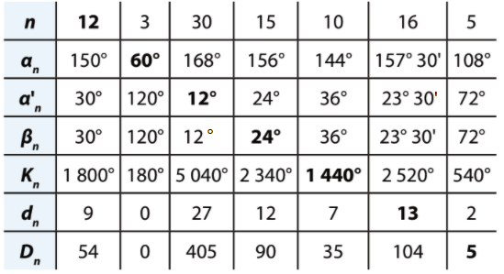

211.
a) n = 8
o = 19.2 cm
a = o : n = 19.2 : 8= 2.4 cm

b) n = 8
a = 0.504 m= 50.4 cm
a = o : n = 50.4 : 8 = 6.3cm

c) n = 8
a = 42 cm
a = o : n = 42 : 8 = 5.25 cm

d) n = 8
a = 0.32 m= 32 cm
a = o : n = 32 : 8 = 4 cm

212.
a)
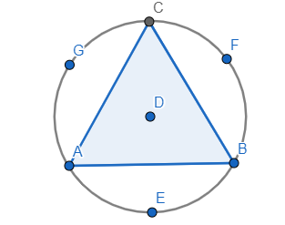
b)
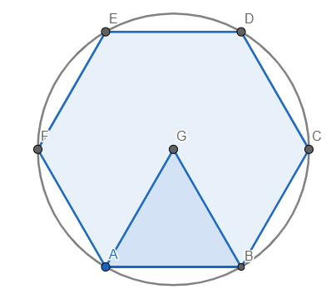

c)
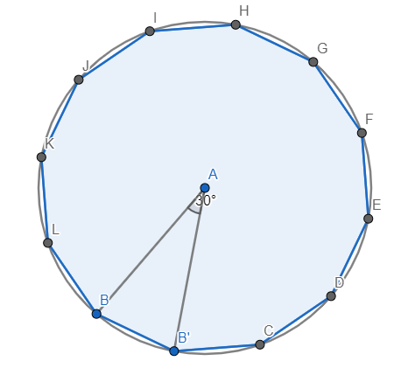

213.
a) n = 8
β=360 : 8 = 45°
γ=(180°- 45°) : 2 =67.5°
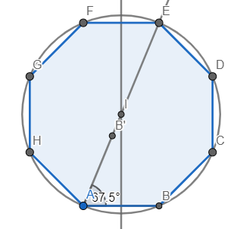

b) n = 9
β=360 : 9 = 40°
γ=(180°- 40°) : 2 =70°
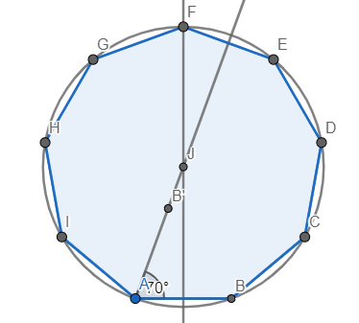
c) n = 10
β=360 : 10 = 36°
γ=(180°- 36°) : 2 =72°

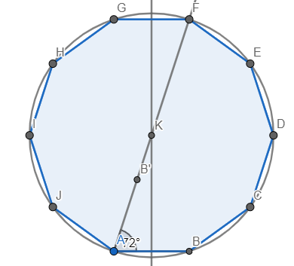

d) n = 12
β=360 : 12 = 30°
γ=(180°- 30°) : 2 =75°
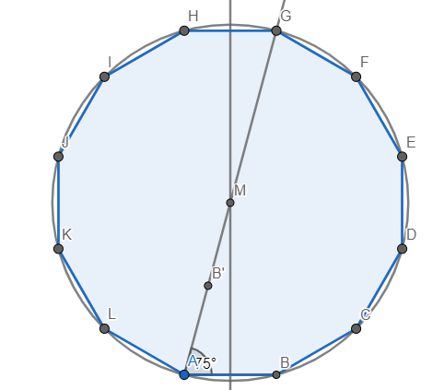
214.
a) n =3
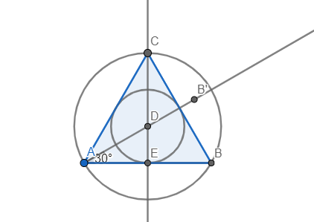
b)
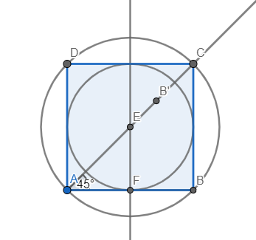
c)
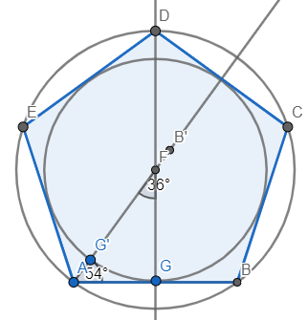

d)
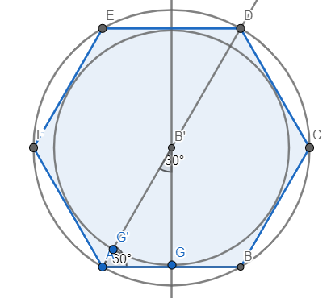

215.
a) $β_{n}=120°$
n=360 : $β_{n}=360°:120°=3$
$$ρ=2.2cm$$
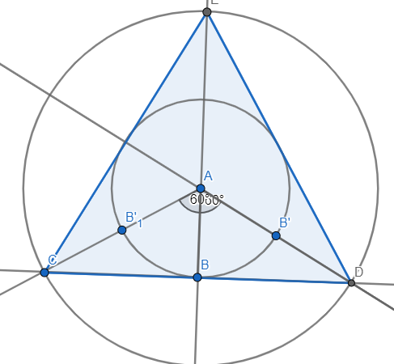

b) $β_{n}=90°$
n=360 : $β_{n}=360°:90°=4$
$$ρ=2.2cm$$
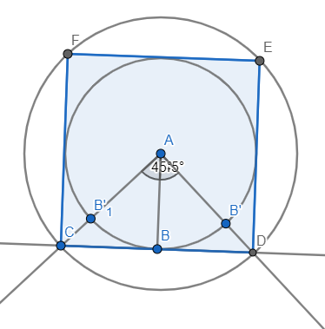
c) $β_{n}=72°$
n=360 : $β_{n}=360°:72°=5$
$$ρ=2.2cm$$
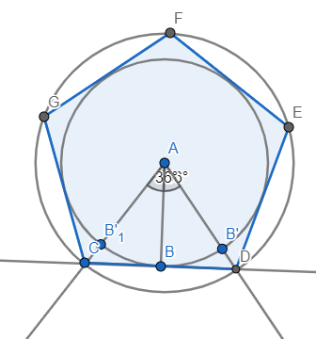

d) $β_{n}=60°$
n=360 : $β_{n}=360°:60°=6$
$$ρ=2.2cm$$
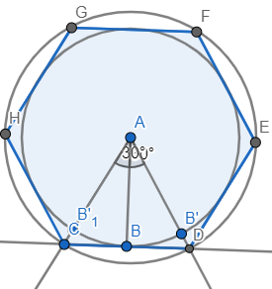

e) $β_{n}=45°$
n=360 : $β_{n}=360°:45°=8$
$$ρ=2.2cm$$
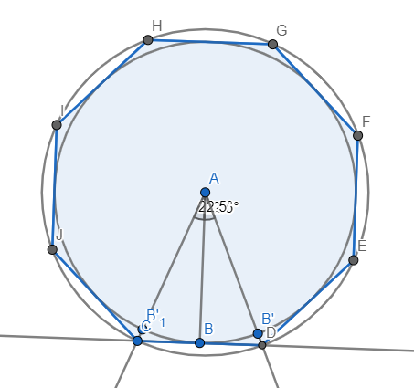

216.
a = 2.4 cm
n=15
$$ρ=5.65cm$$
o =n·a=15 ·2.4 = 36 cm
$$P=n∙\frac{a∙ρ}{2}=15∙\frac{2.4∙5.65}{2}=101.7cm^{2}$$

217.
$$P=\frac{4.5∙3.1}{2}+\frac{4.5∙2.2}{2}=6.975+4.95=11.925 dm^{2}$$

218.
$$P=1.44 dm^{2}=144 cm^{2}$$
v_{a}=6 cm
a = 2P : v_{a}=288 : 6 = 48 cm

219.
o = 73.6 cm
4a = 73.6 /:4
a = 18.4 cm
P=a·a=18.4·18.4 =338.56 cm²

220.
P=1 dm²
a·a= 1
a = 1 dm
o=4a = 4·1= 4 dm
221.
o=29.2 cm
a=6.6 cm
o=2a+2b
2·6.6 + 2b=29.2
13.2 + 2b = 29.2
2b=29.2-13.2
2b=16 /:8
b=8 cm
P=b·v_{b} =8 · 4.8 = 38.4 cm²
v_{a}= P : a = 38.4 : 6.6 ≈ 5.82 cm

222.
P=29.7 cm²
a=6.6cm
b= P : a= 29.7 : 6.6 = 4.5 cm
o=2a + 2b = 13.2 + 9 = 22.2 cm

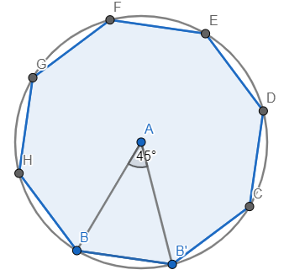
223.
r =3cm
$$α_{n}^{'}=45°=β_{n}$$
n=360°: $β_{n}=360:45=8$
a≈2.33 cm
$$ρ≈2.77 cm$$
o= n·a = 18.37 cm
$$P=n∙\frac{a∙ρ}{2}≈25.46cm^{2}$$

PRIPREMA ZA ISPIT ZNANJA
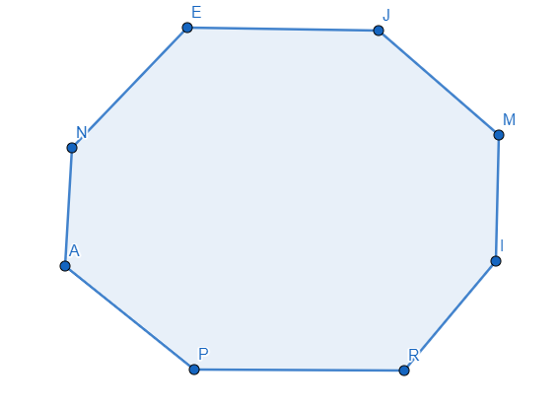
1. c)
2. a) $K_{8}=\left(8-2\right)∙180°=6∙180°=1080°$
b) $D_{8}=\frac{8(8-3)}{2}=20$

3. $K_{n}=2340°$
$\left(n-2\right)∙180°=2340$ /:180
n-2 = 13
n= 13+2
n=15

4. $α_{n}^{'}=20°=β_{n}$
n=360°: $β_{n}=360 :20=18$

5. $d_{n}=7$
n-3=7
n=10
$$K_{10}=\left(10-2\right)∙180°=8∙180°=1440°$$
6. a= 3cm, r = 3cm

7.
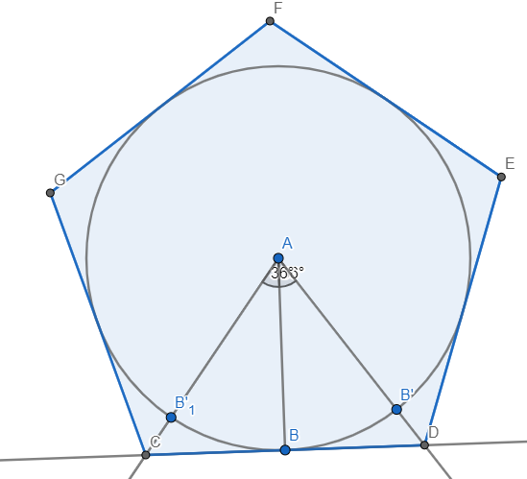
8.
P=17.94 cm^2
a=52 mm =5.2 cm
$$P=\frac{a∙v_{a}}{2}$$
$\frac{5.2∙v_{a}}{2}=17.94$ / ·2
5.2$v_{a}=35.88$ /:5.2
$$v_{a}=6.9 cm$$

9.
a= 3.2 cm
α=135°
β=180°- α=180°-135°=45°
n=360°:β=360 : 45 = 8
o = n·a=8·3.2 = 25.6 cm
10.
α=4β
180°-β=4β
4β+β=180°
5β=180°
β=36°

n=360°:β=360°:36°=10

11.
o = 46.2 cm
$$ρ=7cm$$
$$P=\frac{n∙a∙ρ}{2}=\frac{o∙ρ}{2}=\frac{46.2∙7}{2}=162.4 cm^{2}$$

